Bone Structure
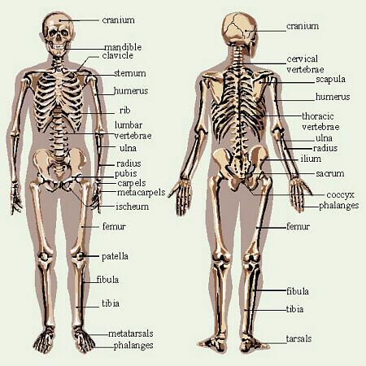
Source: http://biology.clc.uc.edu/courses/bio105/bone.htm

