World Kindness Day Event
Stallholder Information
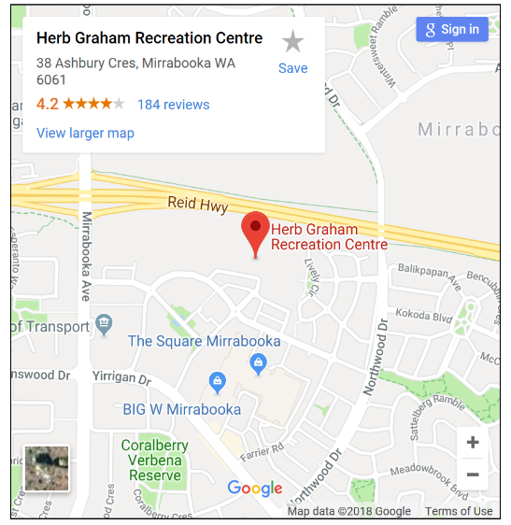
Date: Tuesday 13th November 2018
Venue: The Herb Graham Recreation Centre – 38 Ashbury Crescent, Mirrabooka WA 6061
Cost to host a stall: $50 or FREE for Organisation Members

Items included with your stall:
- 1 x trestle table
- 2 x plastic chairs
You are welcome to bring:
- Pull-up banner
- Flyers and promotional materials
- Give away items

Your Organisation Biography:
When completing the application form, you will be asked to provide a short biography (50 words maximum) about your organisation and how it services health consumers and/or carers. The information you provide will be used for publicity purposes and may be published on the Health Consumers’ Council website and Facebook page

Important dates for your diary:
- Registrations close at 4pm on Friday 19th October 2018
- World Kindness Day Event will be held on Tuesday 13 November 2018

Social media promotion:
We encourage you to promote your involvement with the World Kindness Day through your own networks and on social media.
The official hashtag is #worldkindnessday #healthconsumercouncil

How to register?
Please return completed registration forms to:
Email: info@hconc.org.au
Post: Health Consumers Council, GPO Box C134, Perth WA
For phone queries, please call 08 9221 3422

World Kindness Day Event
Stallholder Terms and Conditions
The following Terms and Conditions apply to stallholders:

- Due to the interest generated, stallholders are required to provide at least one week’s notice prior to the event if withdrawing from the World Kindness Day Event.

- Additional requirements other than what is listed as standard in the information must be requested in writing by the application closing date as stated. Requests after this date will not be considered.

- The Health Consumers Council will allocate a table to you, and all allocations are nonnegotiable. Setting up of table can begin at 11.30am and must be completed by 12:30pm. Your stall should remain open until at least 5pm and must be cleared by 6pm at the latest.

- There is free parking for up to 3 hours. As participant to the event, you can get a day parking permit at reception and display in your dashboard.

- Your staff members and/or volunteers working at your stall will be responsible for securing your products and/or equipment. The Health Consumers Council will not be held liable for any stolen or damaged products and/or equipment.

- The World Kindness Day is a smoke and alcohol-free event. Should you be found smoking or drinking on the premises, you will be asked to leave.

- Stallholders who wish to hold a raffle are to contact the winners themselves.

- As this is a free community event, selling of any goods, services or products is not permissible.

World Kindness Day Event
Stallholder Registration Form
Date: Tuesday 13th November 2018 | 12:30pm – 5pm
(set up before 12:30pm and pack up from 5pm)
Venue: Herb Graham Recreation Centre,
38 Ashbury Crescent, Mirrabooka WA 6061
Registrations close at 4pm on Friday 19th October 2018

Name of Organisation: _______________________________________________

Cost: Please send an invoice for $50 FREE as a member of HCC

Contact Person: ____________________________________________________

Postal Address: _____________________________________________________

_________________________________________________________________

Contact Email: _____________________________________________________

Contact Number: ___________________________________________________

Mobile Number: ____________________________________________________

Please supply a copy of your public liability insurance (select):
Yes, attached

No, will send separately

Does your organisation have any additional requirements?
__________________________________________________________________

__________________________________________________________________

__________________________________________________________________

Please provide a short biography of your organisation (maximum of 50 words) below:

___________________________________________________________________

___________________________________________________________________

___________________________________________________________________

___________________________________________________________________

___________________________________________________________________

___________________________________________________________________

___________________________________________________________________

___________________________________________________________________

____________________________________________________________________

____________________________________________________________________

Website Address: _____________________________________________________

I give permission for my business/organisation details to be advertised through the World Kindness Event and the Health Consumers Council‘s website, social media and promotional products developed for the World Kindness Day event.
I agree to have my stall set up by 12:30pm and will remain onsite until 5pm. I confirm that I will promote the event through my contacts.

Name: _______________________________________ Date: ___________________

Signature: __________________________
Please return completed registration forms to:
Email: info@hconc.org.au
Post: Health Consumers Council, GPO Box C134, Perth WA 61
For phone queries, please call 9221 3422.

