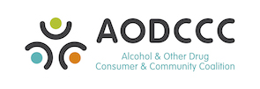

November Update

This update highlights key activities and achievements for the month of October.
October highlights:
- Current membership stands at 193 with the acceptance of 12 new members this month.
- Finalisation and publishing of the organisational Mission, Vision and Values.
- Delivery of our first Progress Report to the Mental Health Commission.
- Strategic planning training and development workshops in preparation for our February deliverables.
- Progressed Annual Report.
- Progressed business and marketing merchandise.
- Commenced website development.
- Successful audit completed.
- 10 nominations for the Management Committee received.

Other items:
A reminder that our second AGM is set for the 9th of December, 5.30-6.30pm at the Dome Café in Maylands, we hope to see you there.
On another note, we are sad to say goodbye to our Secretary Grant Smith and we wish to take this opportunity to thank him for his hard work in this role over the past 9 months.

