Has someone helped you have a positive experience of the health system?
Patient Experience Week is an opportunity to celebrate and acknowledge the ways that staff in health services can have a positive impact on the experience that consumers, carers and family members have of the health system.

If someone has helped you have a positive experience in the health system, why not complete one of these cards with their name and a note about what they did that made a difference? Then just either hand it to the staff member involved – or to another member of staff on the team.

Saying thank you can lead to a 50 per cent increase in helpfulness! So by expressing your thanks for a job well done, you could be helping to make the health system just a bit better!
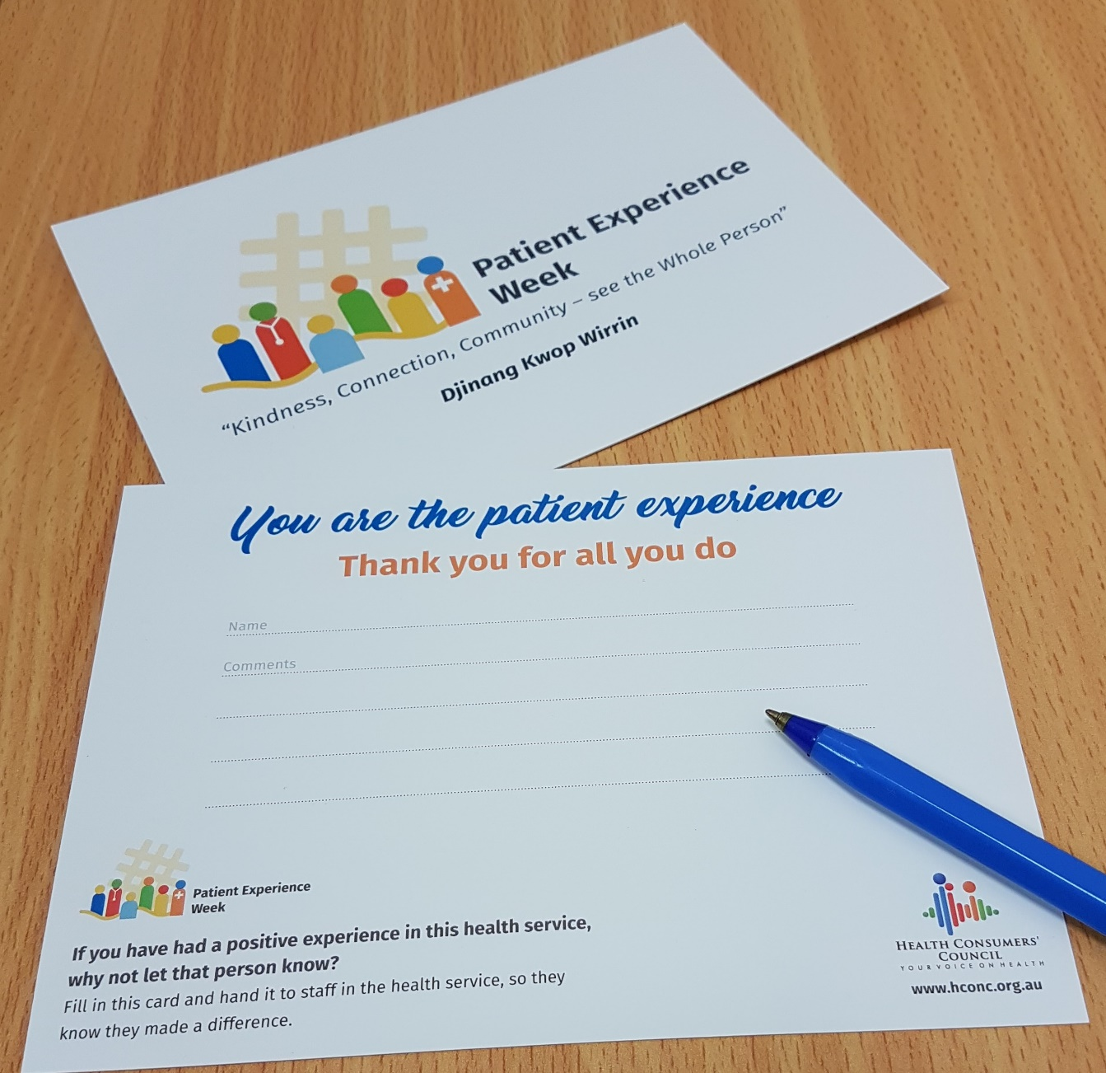

https://hbr.org/2013/11/the-big-benefits-of-a-little-thanks

