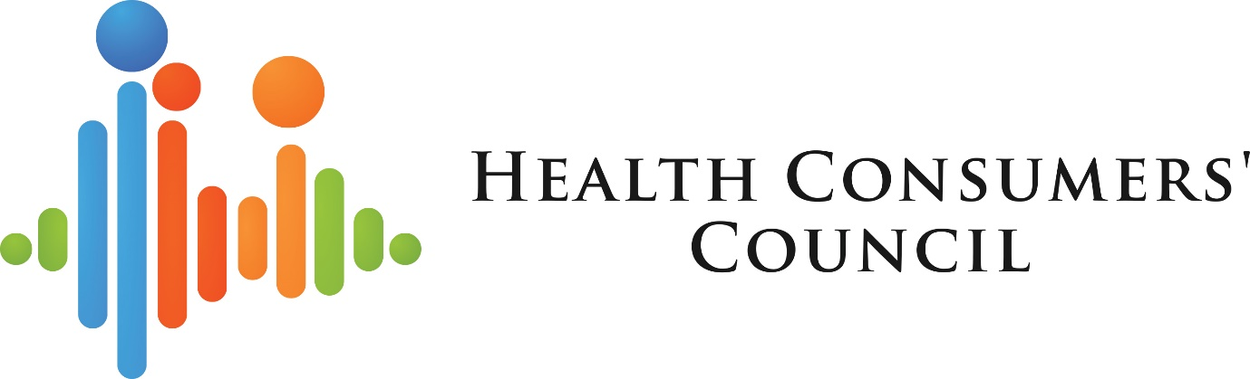

Diversity Dialogues Forum

11 November 2020

CaLD Youth Mental Health

Diversity Dialogue 2020 - Exploring challenges around CaLD youth mental health
Overview

The purpose of this forum was to improve the ability of attendees (health service providers) to support Culturally and Linguistically Diverse (CaLD) youth in their mental health journeys. The session was planned to explore some of the complex and unique challenges faced by multicultural youth in Australia in regards to facing mental health issues and navigating diagnosis and treatment and some of the opportunities to overcome barriers. This forum was held in partnership between the Health Consumers’ Council (HCC) and Consumers of Mental Health WA (CoMHWA).

The forum took place in November 2020 and was conducted online via Zoom. This was in part due to the COVID-19 pandemic (wanting to avoid organising large face to face events in case of restrictions on gatherings being implemented) also following the success of our online Diversity Dialogue earlier in the year and the realisation that online offers a wider reach and therefore greater impact. There were 162 registrations for the event with 76 attendees. It is possible that some registrants planned to watch online at a later date although best efforts were made to try and publicise the fact that the event would not be recorded due to the sensitive nature of the discussion.
The event was co-chaired by our Cultural Diversity Engagement Coordinator and a CoMHWA Project Coordinator who focuses on CaLD and is also a CaLD young person herself. The panel also consisted of a representative from the Multicultural Youth Advisory Network WA (MYANWA), a CaLD youth mental health advocate and two young people with personal, lived experience of mental health diagnoses and treatment.
Panel co-chairs:
- Nadeen Laljee-Curran – Cultural Diversity Engagement Coordinator, HCC
- Neeka Zand – Project Coordinator, CoMHWA
Panellists:
- Zinab Al Hilaly – Project Officer, Multicultural Youth Advocacy Network WA
- Harsha Mahinda-Yogam – volunteer and advocate, Mission Australia and Youth Affairs Council of Western Australia
- Rumbidzai Mudzengi – lived experience, cultural background Zimbabwean
- Sachin North – lived experience, cultural background South African and Indian
Speaker biographies are available in the appendix on page of this report.
The audience acknowledged the power and impact of lived experience and really benefited from hearing from such a strong panel. Heartfelt thanks go to all panel members for their participation and invaluable input.

Content of Discussion
The session was opened with an acknowledgement of country and also an acknowledgment of Remembrance Day. The HCC chair introduced the topic firstly by mentioning her own connection to it and also by explaining that there is significant under utilisation of mental health services by CaLD communities and typically presentation of youth is at an older age (when the problem is often more developed). Over 75% of mental illness is symptomatic before 25 years of age and so supporting young people and their families to getting earlier diagnosis as treatment is important for better health outcomes. She touched on some of the unique challenges and barriers as well as unique opportunities which would be explored in the discussion.
Although this was not stated publicly in the forum, the chairs set key topics of discussion or themes which were informed by research and experience in the sector. These were, identity, Stigma and normalising the discussion around mental health (family barriers, community barriers and health service provider barriers), culturally sensitive and insensitive practice and ways to support youth. Preprepared questions around these topics were posed to the panellists for the first part of the session and approximately fifteen minutes of questions from the audience followed.
All the panellists said they or those they have supported, struggled with identity. There was a feeling of a lack of belonging in Australian society or in the community of religion or country of origin. Some panellists commented that they are not recognised as Australian even though they are by birth and nationality. There was talk of gravitating to those of similar skin colour at school and finding it hard to relate to white children but some panellists also felt a lack of belonging with black children. The complexity of mixed-race families was mentioned. One panellist spoke in detail about [societal / community] racism, racial profiling, and stereotyping and how it affected his mental health. Another panellist spoke about how stereotyping and generalising comments from a health service provider was initially a barrier to her accessing mental health treatment.
The discussion them moved on the label of “CaLD” and whether it is useful or not. Although the panellists felt the label refers to a very diverse group of peoples with different needs and issues, CaLD staff and liaison officers can make a service feel more safe and approachable. All felt the label was not person centred enough and the most important things are:
  - Being open to people
  - No assumptions
  - Stereotyping and assumptions are an issue with young people
  - No judgement
  - Let young people establish their own boundaries
In general services need more cultural awareness training, once isn’t enough and a higher level of cultural competency is needed. Again, racism featured as a big problem with acknowledgment that services need to be more trauma informed and understand that young people might have experienced trauma and racism. Panellists also noted that young people can be scared of people with more perceived power than them.

The discussion about barriers was a lengthy one with key points as follows:
- Culture, heritage, community, religion and family all clearly have a part to play in the way we understand mental health.
- Different Cultures see mental health differently.
- Wellbeing also means different things in different cultures.
- There can be a fear to approach family, a fear of rejection.
- Confidentiality is a big fear. Everyone in community knowing private business.
- There can be guilt over our privilege compared to others in the community or family overseas.
- There can be feelings of a lack of validity around mental health issues due to the hardships endured by parents in their asylum seeking or migration.
- Families might not understand the mental health system and don’t trust it.
- Mixed families have mixed views – who do you go to? Who do you favour?
- Some doctors have the same cultural background as family (parents might select a GP from the same culture om purpose). The challenge here can be that they have the same views as family. So, one might not get a diagnosis or treatment.
- Mental health literacy is low. Many communities do not know what mental health means, what services are available.
- Mental Health awareness programs do not focus on CaLD.
- Doctors don’t routinely mention or ask about Mental health, and if kids do, its dismissed.
- Racism is ignored by health services.
- People talk about their bad experiences which stops others from accessing.
- Unconscious racism of clinicians stops some youth accessing services that could be good.
- As well as dealing with their own mental health issues CaLD youth can have to deal with being made to feel ashamed of where they are from (‘oh sexual abuse is common with your community’ said to a panel member by a health professional as an example).
- Cost of Mental Health services can be very high, unaffordable for young people.
- We need more support for international students and non-citizens.
The discussion then moved onto what is helpful and what works. The young people mentioned the power of peer-to-peer support and also storytelling in terms of a) normalising mental health in communities and b) supporting young people. The How’s your Haal programme was mentioned as an example. The importance of self-advocacy skills and empowering young mental health advocates and young people in general to advocate for themselves (and in some cases the generation above them). Looking through the community health lens not the tertiary or medical lens was considered important as was co-design.
The discussion ended with each panellist telling the audience one thing they wanted health service providers to know. The theme seemed to be person centred or more specifically:
- Acknowledge difference but don’t generalise.
- Look at the person as a whole being and advocate for them. Ask questions and think! Think about costs, location etc.
- You will directly impact this person’s life. Health workers need diversity in life too. Always see people as they are.
- Ask questions, build relationships, let people feel safe to open up.
- Link people to services.
Evaluations
There were 30 feedback survey responses. The survey response of 39% is higher than what we perceive to be normal for a webinar of this nature and it seems people took the time to respond because they wanted to give extremely positive feedback. Some people even emailed feedback directly. 100% of respondents found the webinar to be a valuable use of their time with 73% feeling that they had an increased understanding of the issues around CaLD youth mental health and 63% feeling the webinar would help them in their role.
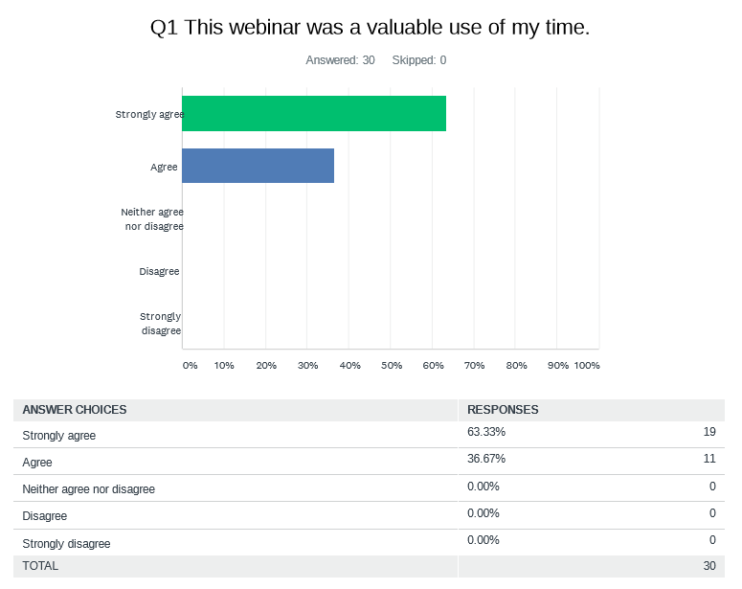
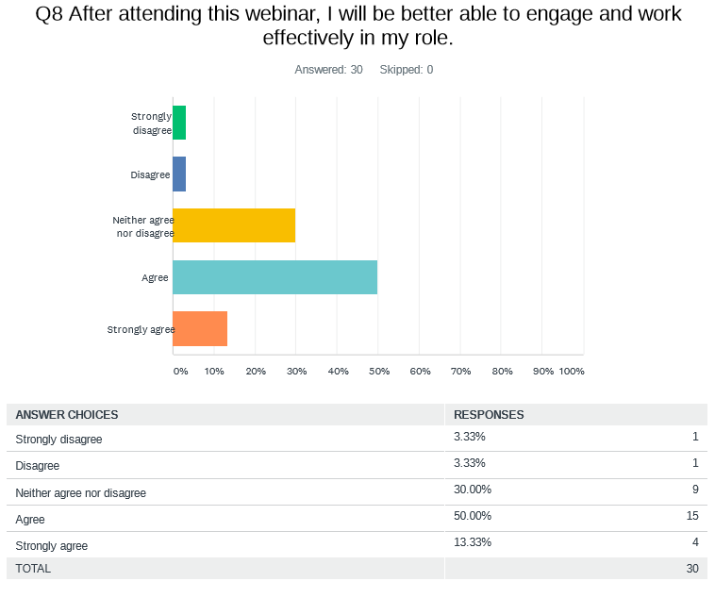
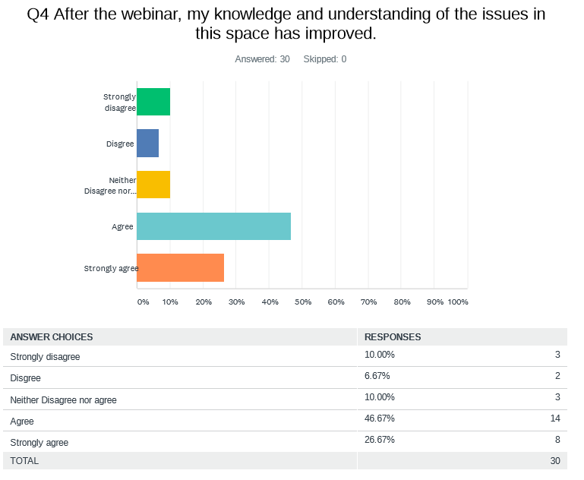

We did not record the event due to the sensitive nature of the discussion and the audience commented how powerful, impactful, insightful and useful the lived experience commentary was. 23 respondents (77%) took the time to write a comment about the strength of the panel. There were actually no negative comments about the discussion with the only slightly negative comments about the event being about the length (it could have been longer, some participants suggested 90 minutes as opposed to an hour) and technology as there were internet issues in the HCC office which resulted it being hard to hear to co-chairs. One participant felt that comments (from other participants) were “patronising”.

Once again, thanks to all who participated.
Should you be interested in further workshops or forums held by HCC please visit the website at: https://www.hconc.org.au/ to see what is available or call on 9221 3422. Sessions can also be tailored to the needs of individual agencies and departments.

Appendix 1 – Resources

During the discussion the panellists mentioned Headspace, The Multicultural Youth Advocacy Network of Western Australia (MYAN WA) and How’s Your Haal (report available here). Links to these organsaitons / report were sent out in the Zoom chat function and by email after the event. The Embrace Multicultural Mental Health Framework portal was also sent out as a link by email post event.
Appendix 2 – Speaker biographies

Nadeen Laljee-Curran (Health Consumers’ Council)

Nadeen is Cultural Diversity Engagement Coordinator at the Health Consumers’ Council (HCC). She has a background in public health and is passionate about patient centred care as well as helping people from diverse backgrounds understand our West Australian health system and get the best benefit from it. Nadeen was born in the UK to Indian parents who had themselves migrated from Africa. Growing up in the UK she was acutely aware of some of the identity challenges faced by children of migrants and some of the cultural challenges around mental health diagnosis and treatment.

Neeka Zand, Project Coordinator (Consumers of Mental Health WA (Inc.))

Neeka is a project coordinator at the Consumers of Mental Health WA (CoMHWA). She has a bachelor’s degree in psychology and commerce and that together with her own cultural background and upbringing have led her to be focused on the CaLD, mental health and human rights fields. Neeka is passionate about making mental health services more accessible and effective for CaLD communities. Being raised by parents that were refugees from Iran, yet having the opportunity to be raised in Perth, has really helped her to recognise some of the unique hurdles that CaLD individuals face in their mental health journeys.

Zinab Al Hilaly, Project Officer, Multicultural Youth Advocacy Network WA

Zinab Al Hilaly is the Project Officer at the Multicultural Youth Advocacy Network of Western Australia (MAYAN WA) at the Youth Affairs Council of Western Australia (YACWA). From seeing the barriers and health disparities within her community, Zinab is a dedicated and passionate advocate on a multitude of issues including the rights of migrant and refugee people, youth leadership, women’s rights, mental health and community health. As a CaLD young person she continues to seek ways to increase opportunities, empower and advocate for people from marginalised backgrounds.

Harsha Mahinda-Yogam

Harsha is a young psychology graduate who currently works/volunteers in the youth mental health sector across organisations such as Mission Australia (Alcohol and Other Drugs), and YACWA (Part of a Youth Steering group advocating for governmental changes to help Migrant/Refugees following COVID-19). Harsha has previously worked with Headspace Armadale, and been part of YMCA’s Inside Our Minds campaign to raise awareness of Mental Health stigma in CaLD communities. Being a migrant himself, Harsha experienced some difficulties adjusting into the Australian culture when he first moved, but he greatly benefited from the support he received from his family, and their awareness to tie him into local councils/programs that enabled him to assimilate into his new community through sports.

Rumbidzai Mudzengi

Rumbidzai (Rumbiie) migrated to Australia from Zimbabwe with her family when she was 14 years of age. She has been working in the African community bringing awareness to issues on Mental Health as a speaker and advocating for Minority Economic Empowerment through her Networking series for creatives and business start-ups. She uses her knowledge and lives experience with childhood trauma / abuse and suicide to raise awareness on the dangers of mental health stigma while showing others that we all have the innate ability to rise above any challenge that we may come across and become the best version of our selves.

Sachin North

Sachin North is a young, first generation Australian. Both his parents immigrated, his father from Madras, India and mother from Cape Town, South Africa. Sachin has lived experience of his own journey with mental health and physical health issues from a young age and as such he is passionate about helping other young people. Sachin has been on the Headspace, Armadale, Youth Reference Group for the past two and a half years and is currently studying to work in the community services sector.

